

Clinical Trials of Medicinal Products in Ukraine

Information Booklet

Kyiv
2021

Clinical trials play an important role in the development of new medicinal products, because the decision on the possibility of their medical use can be made only after a systematic study in humans and obtaining evidence of efficacy and safety.
New medicinal products, regardless of the country in which they were developed, must be evaluated on the basis of adequate data of the studies conducted according to a uniform set of requirements, including the rules of Good Clinical Practice. The current GCP requires the cooperation of all industry stakeholders, researchers, government agencies responsible for the registration and control of medicinal products (MPs), and ethics committees. GCP rules are considered as a prerequisite for proper clinical trials in most developed countries.
In recent years, regulatory documents to improve examination of materials and conduct of clinical trials (CTs) have been developed and implemented. This demonstrates a gradual approximation to international standards for CT.
Legislative and regulatory framework of Ukraine for conducting clinical trials:
The Law of Ukraine “On Medicines” as amended;
“Clinical Trials Guideline. Medicinal products. Good Clinical Practice. Guideline 42-7.0: 2008” approved by MoH Ukraine Order No. 95 of 16.02.2009. This Guideline was developed on the basis of Note for Guidance on Good Clinical Practice, СРMР/ICH/135/95 (Е6), 1997.
In 2017 the MoH Ukraine Order of 26.09.2017 № 1169 amended the Guideline 42-7.0: 2008 to implement Integrated Addendum to ICH E6 (R1): Guideline for Good Clinical Practice E6 (R2) Current Step 4 version dated 9 November 2016. In order to improve the conduct of clinical trials in Ukraine the Procedure for Conducting Clinical Trials of Medicinal Products and Expert Evaluation of Materials Pertinent to Clinical Trials the MoH Ukraine was approved by MoH Ukraine Order of 23.09.2009 № 690 (hereinafter - Order 690). Amendments to the Order 690 implemented a requirement to approve a clinical trial/substantial amendment(s) by MoH Ukraine orders. This envisages a submission of an application for conducting CT of MP/for making a substantial amendment to the CT protocol to the Center for Administrative Services MoH Ukraine "Single Window" (based on “one-stop-shop” principle). The approved orders are published on the MoH and the State Expert Center MoH (SEC) websites. This procedure brought closer the creation of the unified public database of clinical trials conducted in Ukraine (i.e. Register of clinical trials) and made the process of conducting CTs more transparent.
In view of the quarantine imposed because of the COVID-19 pandemic, changes were made to the legislation, namely the Law of Ukraine “On Amendments to Some Legislative Acts of Ukraine on Provision of Treatment of Coronavirus Disease (COVID-19)" of 20.03.2020 № 539-IX) according to which the expert evaluation of materials of clinical trials of medicinal products for treating coronavirus disease (COVID-19) shall be conducted within five calendar days.
In 2020 16 CTs (10 international multicenter CTs and 6 CTs by domestic manufacturers) for the treatment of COVID-19 have been approved according to the current legislation.
Based on results of the expert evaluation 1053 positive conclusions were provided on the conduct of international multi-center CTs and 248 positive conclusions on the conduct of CTs by domestic manufacturers from 2015 to 2020.

 | 2015 | 2016 | 2017 | 2018 | 2019 | 2020 | Total
Oncology | 28 | 30 | 33 | 46 | 42 | 56 | 235
Psychiatry and neurology | 22 | 26 | 29 | 27 | 33 | 37 | 174
Gastroenterology | 24 | 16 | 26 | 29 | 27 | 18 | 140
Rheumatology | 16 | 14 | 23 | 9 | 15 | 10 | 87
Pulmonology | 18 | 14 | 7 | 16 | 10 | 9 | 74
Endocrinology | 9 | 6 | 10 | 9 | 12 | 4 | 50
Cardiology | 4 | 6 | 14 | 8 | 14 | 10 | 56
Hematology | 6 | 5 | 10 | 8 | 15 | 18 | 62
Infectious diseases /COVID-19* | - | - | - | - | - | 16 | 16

Remarks on CT materials

Remarks on CT materials

Remarks on CT materials

Leading applicants for international CTs in Ukraine

Leading applicants for international CTs in Ukraine

Leading applicants for international CTs in Ukraine

Leading applicants for domestic CTs in Ukraine

Leading applicants for domestic CTs in Ukraine

Leading applicants for domestic CTs in Ukraine

* due to the COVID-19 pandemic, clinical audits have been suspended, and after the end of quarantine, clinical audits will be continued.
Since 2012 the Center’s employees have taken part in GCP inspections in Ukraine conducted by inspectors from the USA Food and Drug Administration (U.S. FDA) (6 inspections), the European Medicines Agency (EMA) (4 inspections), the Japanese Pharmaceuticals and Medical Devices Agency (PMDA) (1 inspection) and the Lithuanian State Medicines Control Agency of (SMCAL) (1 inspection).
Inspectors from ЕМА, FDA, PMDA and SMCAL recognized the functioning of the clinical trial system in Ukraine sufficiently developed. Also, they thanked the representatives of the State Expert Center of the Ministry of Health of Ukraine for their participation in the inspections and hoped for future cooperation. Such joint events have shown that CTs in Ukraine are conducted at the appropriate level according to the requirements of the regulatory framework of Ukraine and international standards for clinical trials.
Since 2014, the Center’s staff regularly participates in workshops and training courses for GCP inspectors conducted by the European Medicines Agency (EMA). At these workshops a common approach to conducting CT inspections in the European Union member states was discussed. In 2015, 2017 and 2018 employees of the Clinical Audit Department received certificates after successful completion of “GCP Inspector’s basic training course” from EMA.
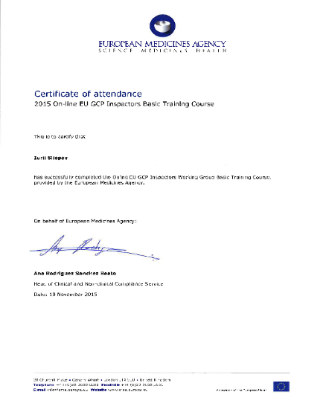
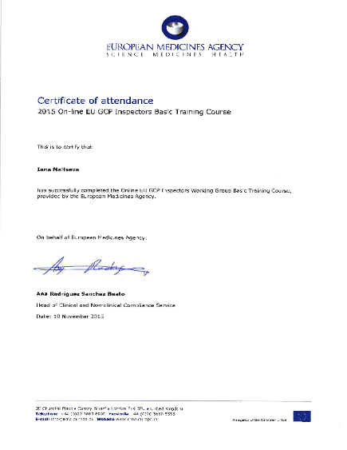
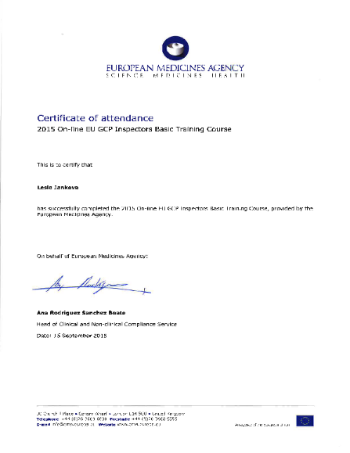
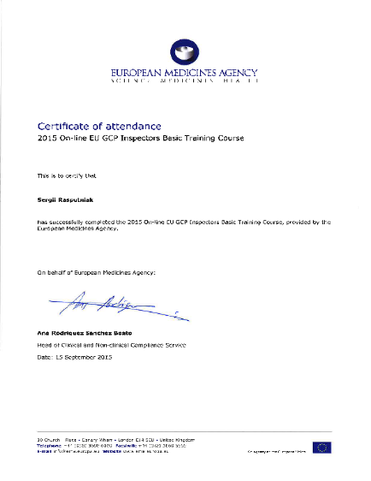

Ukraine has created a regulatory framework that allows the conduct of clinical trials in compliance with international standards. At the same time, the strategy of integration of Ukraine with the EU requires further measures to harmonize the Ukrainian MP regulatory system with relevant EU standards and directives.

